**ST. XAVIER’S COLLEGE**

**(Affiliated to Tribhuvan University)**

Maitighar, Kathmandu



**Database Management System**

**Lab Assignment #4**

**Submitted by:**

Anlisha Maharjan  
013BSCCSIT006

**Submitted to:**

|  |  |
| --- | --- |
| **Er. Sanjay Kumar Yadav**  Lecturer  St. Xavier’s College |  |

**Date of Submission:** August 10, 2015

ER DIAGRAM WITH ONE CASE STUDY

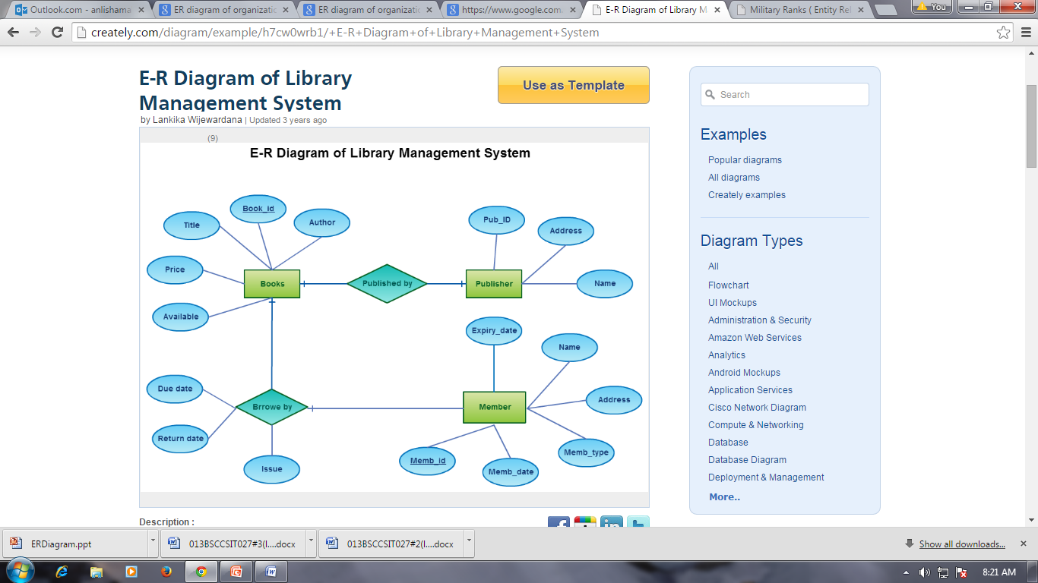

DESIGN:

Database design is the process of producing a detailed data model of a database. This logical data model contains all the needed logical and physical design choices and physical storage parameters needed to generate a design in a data definition language, which can then be used to create a database. [1] FUNCTIONAL DESIGN:

Functional design is the design method in which the system is seen from the functional viewpoint. The design concentrates on isolating high-level functions that can then be decomposed into and synthesized from lower-level functions. [2]

The standard way to assure functional design is to review the description of a module. The responsibilities need to be divided into several modules in order to achieve a functional design.

DATABASE DESIGN:

-Conceptual database design:

|  |  |  |
| --- | --- | --- |
| conceptual-model-design.jpg |  |  |

-logical database design

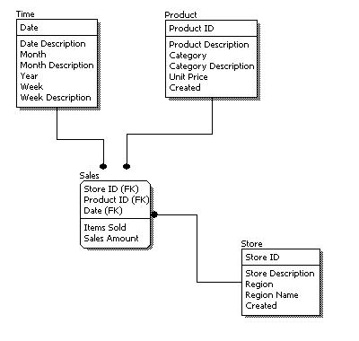

-physical database design

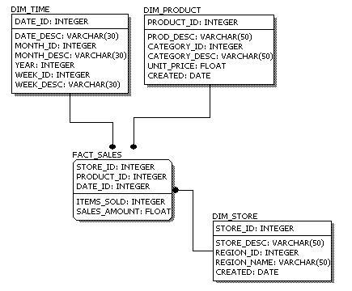

CHARACTERISTICS OF RELATION:

ER TO RELATIONAL MAPPING ALGORITHM:

MAPPING OF MULTIVALUED ATTRIBUTE

REFERENCES:

[1] Tomjewett.com,. 'Database Design - Introduction'. N.p., 2015. Web. 10 Aug. 2015.

[2] Encyclopedia.com,. 'Functional Design – Dictionary Definition Of Functional Design | Encyclopedia.Com: FREE Online Dictionary'. N.p., 2015. Web. 10 Aug. 2015.